Project 19-1: Add customer incidents
For this project, you’ll develop an application that lets the user display the incidents for a selected customer and add incidents for that customer.
The design of the Customer Incidents form
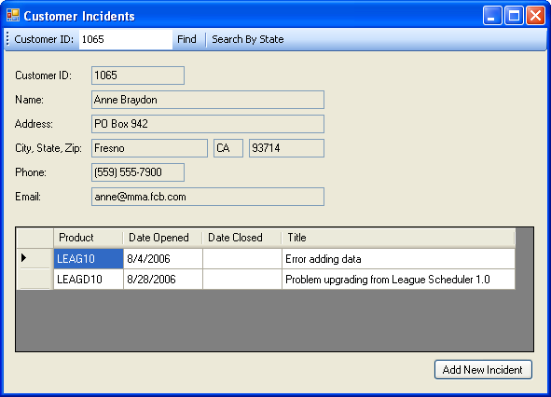
Operation
- When this application starts, a blank Customer Incidents form is displayed.
- To retrieve a customer, the user enters a customer ID and clicks the Find button. Then, the customer data for the customer with that ID is displayed in the text boxes and the incidents for that customer are displayed in the DataGridView control. If a customer with the specified ID isn’t found, an error message is displayed.
- The user can also select a customer by clicking the Search By State button to display the Find Customer form.
- To add a new incident, the user clicks the Add New Incident button to display the Add Incident form.
The design of the Find Customer form
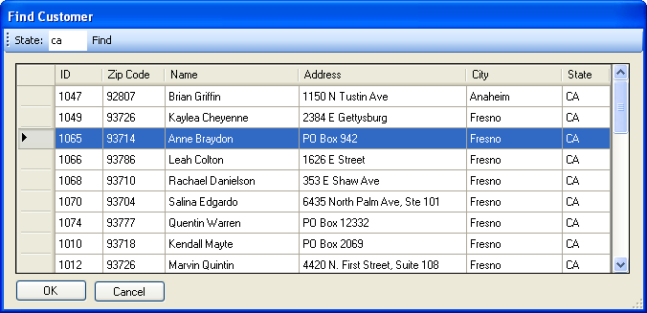
Operation
- To find a customer, the user enters one or more characters of the state code and clicks the Find button to display all the customers with state codes that begin with those characters in the DataGridView control. If no customers are found, an error message is displayed.
- To select a customer, the user can double-click on the row for that customer or click on the row and then click the OK button.
- To close the form without selecting a customer, the user clicks the Cancel button.
The design of the Add Incident form
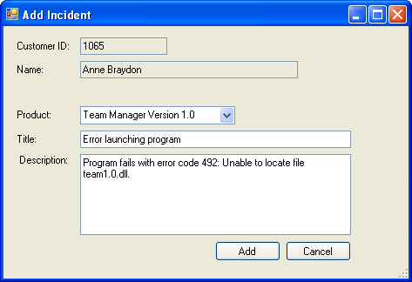
Operation
- To add an incident, the user selects a product from the combo box, enters a title and description, and clicks the Add Incident button to add a row to the Incidents table, update the database, and close the form.
- To close the form without adding an incident, the user clicks the Cancel button.
Specifications
- Create a data source with three tables: Customers, Incidents, and Products. Include all the columns in the Customers table, all the columns except for TechID in the Incidents table, and the ProductCode and Name columns in the Products table.
- Add two queries to the Customers table adapter. The first one should retrieve the data for a customer with a specified ID and should be used to display the customer data on the Customer Incidents and Add Incident forms. The second one should retrieve the customers with a state code that starts with the characters specified on the Find Customer form. This query should sort the resulting rows by city.
- Add a query to the Incidents table adapter that retrieves the incidents for a specified customer. This query should be used to display the incidents on the Customer Incidents form.
- Add a query to the Products table adapter that retrieves the products that are registered to a user. To do that, you can join the Products table with the Registrations table and return only the rows for the products in the Registrations table for the selected customer. These products should be displayed in the combo box on the Add Incident form.
- Check that a customer is selected on the Find Customer form when the user clicks the Add button. If no customers are displayed in the DataGridView, no customer is selected. Otherwise, the first customer is selected by default.
- Check that a customer is selected on the Customer Incidents form when the user clicks the Add Incident button. If not, display an error message.
- Validate the data on the Add Incident form to be sure that a title and description are entered.
- Use properties and methods of the Incidents table in the typed dataset that’s generated when you create the data source to add new rows to the table.
- After a new incident is added, be sure to update the DataGridView control in the Customer Incidents form so it displays that incident.
- Use error handling as necessary throughout this application.
Notes
- This is a complex project that requires three forms, a data source with three tables, parameterized queries, customized toolbars, code that works with a typed dataset, and code that works with a DataGridView control. To make it easier to complete, the specifications include information about the data sources and queries.
- To simplify this project, you can omit the Find Customer form and just rely on the user entering a customer ID.
- To enhance this project, you can add a form that lets the user add and modify customers. This form could work with the CustomersBindingSource using code.

